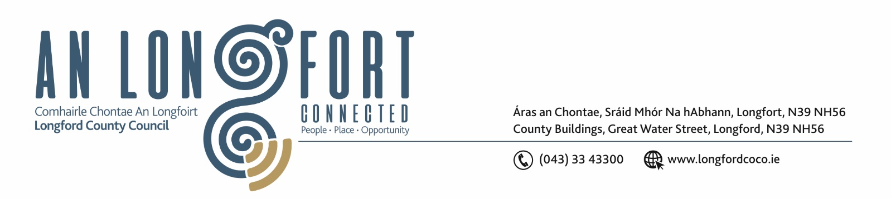

28th November 2019.

Chuig: Gach Ball don Chomhairle.

A Chomhairleoir,

I wish to inform you that the Special Meeting of Longford County Council which was due to take
place next Monday, 2nd December 2019 at 5.00 p.m. is cancelled.

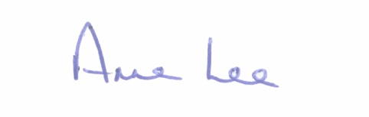
Mise le meas,

__________________
Anne Lee,
Meetings Administrator.



